

**Name: Agristores Technologies**

**Date created: Sep 24, 2021**

**Date modified: Dec 28, 2021**

Contents

PLANNING 2

ANALYSIS 3

DESIGN 4

IMPLEMENTATION 5

MAINTENANCE 6

SECURITY 7

# PLANNING

## Introduction

Agristores-technologies is an online e-commerce platform where local farmers can upload galleries of agricultural items such as legumes, clothing, cash-crops etc. in order to get connected to a global range of customers. Agristores-technologies has several subsidiary companies such as Agripay, Agrinews and Agrinow etc. which offer more related services.

## Requirements Gathering

Create a website that allows users to create business portfolios for their agricultural businesses. The website should feature the top trending portfolios and available items. It should also allow searching for an item on the site with filtering of price, condition whether used, new or imported in order to suit customer needs. The website should allow users to contact the support team.

## Conclusion

In conclusion, Agristores-technologies offers an e-commerce solution to an agricultural market.

# ANALYSIS

## Introduction

A series of steps was followed to determine the requirements of the Agristores-technologies website

## Feasibility analysis

1. Economic feasibility – Agristores-technologies aims to make returns on investments made by getting payments from customers which in turn are divided among merchants and the company’s financial department
2. Technical feasibility – Agristores-technologies makes use of github in order to provide a platform to interact with users until a domain is purchased in future

## Conclusion

In conclusion, the company aims to implement a low cost structure in its startup phase and later on branch to production-level technologies when investors arrive.

# DESIGN

## Introduction

A modern design scheme was used to create v1.0.0 of the Agristores-technologies online platform

## Web architecture

1. index.html – refers to the hypertext markup language file that places visible items on Agristores-technologies web page <http://github.com/greatsilas23/Agristores-technologies/blob/gh-pages/index.html>
2. styles.css – refers to the cascading style sheet file that formats and arranges visible items on Agristores-technologies web page <http://github.com/greatsilas23/Agristores-technologies/blob/gh-pages/styles.css>
3. script.js – refers to the javascript file that handles client side requests
   1. <http://github.com/greatsilas23/Agristores-technologies/blob/gh-pages/script.js>
4. app.js – refers to the javascript file that handles data storage operations <http://github.com/gratsilas23/Agristores-technologies/blob/gh-pages/app.js>

## Microservices and API

1. API for global positioning system to determine route followed when delivering items
2. Localstorage microservice to track user requests

## Web Frameworks

1. React js – a javascript frontend web framework for the Agristores website is available on the main branch of the github repository
2. node js – javascript backend framework using Chrome’s V8 is available on the main branch of the github repository
3. mysql – a database service is available on the main branch of the github repository

## Conclusion

The use of relevant web technologies makes Agristores-technologies a top tier online platform that can compete with other companies in the same market niche

# IMPLEMENTATION

## Introduction

A series of steps was followed to phase out the old system and introduce an online platform for operations within Agristores technologies. An pilot implementation scheme was used after user training was performed within the company employees.

## User training

The following users were trained in use of the Agristores-website

* 1. CCO – chief coordination officer
  2. CIO – chief internal officer
  3. CEO – chief executive officer
  4. COO – chief operations officer
  5. CTO – chief technology officer
  6. CRO – chief relations officer
  7. CS – company secretary

## Pilot Implementation Scheme

After following the outlined procedure, the following website illustrated below was created and used alongside the existing system until the date when a real-world domain will be purchased by funds from investors

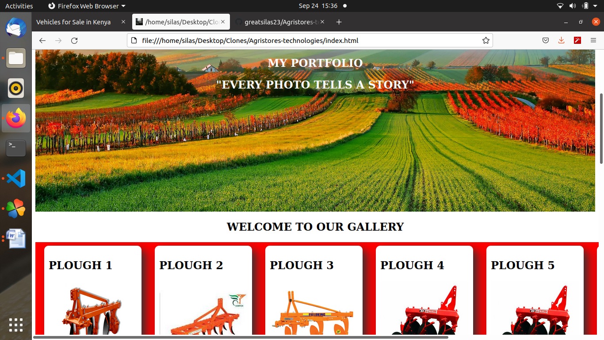  
Illustration 1: Agristores-technologies v1.0.0

## Conclusion

The procedure yielded a website that is attractive and easy to navigate through accessible through github pages <http://greatsilas23.github.io/Agristores-technologies>

# 

# MAINTENANCE

## Introduction

Periodic meetings and updates are performed on the Agristores-technologies platform in order to correct inconsistencies and introduce new changes

## Maintenance schedule

Agristores solved the problem statement by providing a platform for prospective customers to connect with farmers and stores. White it is claimed that agriculture is a traditional field that should be handled by middlemen and food storage agencies, it is true to claim that an online platform to buy and sell farm produce and equipment will expand the field of agriculture.

## Conclusion

Agristores was successful in the following ways:

1. Providing users with a responsive design that minimizes lag
2. Providing a sustainable source of clients and customers for farmers who sign up and create new portfolios

# **SECURITY**

## Introduction

Agristores-technologies website has been built to counter the following types of attaks by malicious users

* DOM Cross Site Scripting payload attacks
* Reflected Cross Site Scripting payload attacks

## Conclusion

Agristores-technologies online platform is secure. It provides a safe experience for users wishing to purchase items